Case Study 3

Title: To design a web application with a login system that allows only authenticated users to access a Semester Grade Sheet, where students can enter their marks and get their SGPA calculated automatically.
Program code:-
<!DOCTYPE html>
<html lang="en">
<head>
<meta charset="UTF-8">
<meta name="viewport" content="width=device-width, initial-scale=1.0">
<title>Semester Grade Sheet | SIT</title>

<style>
* {
margin: 0;
padding: 0;
box-sizing: border-box;
font-family: "Segoe UI", Arial, sans-serif;
}

body {
background: #f4f6f9;
color: #1f2937;
}

/* ================= LOGIN ================= */

#loginPage {
min-height: 100vh;
display: flex;
align-items: center;
justify-content: center;
background:
linear-gradient(135deg, #680000, #a40000 45%, #350000);
padding: 20px;
}

.login-wrapper {
width: 950px;
min-height: 560px;
display: grid;
grid-template-columns: 1fr 1fr;
background: white;
border-radius: 22px;
overflow: hidden;
box-shadow: 0 25px 70px rgba(0,0,0,0.25);
}

.login-brand {
background:
linear-gradient(145deg, #750000, #b51212);
color: white;
padding: 60px 50px;
display: flex;
flex-direction: column;
justify-content: center;
}

.logo {
width: 65px;
height: 65px;
border-radius: 15px;
background: rgba(255,255,255,0.15);
display: flex;
align-items: center;
justify-content: center;
font-size: 30px;
margin-bottom: 25px;
}

.login-brand h1 {
font-size: 34px;
line-height: 1.2;
margin-bottom: 15px;
}

.login-brand p {
color: #f6dede;
line-height: 1.7;
font-size: 15px;
}

.brand-line {
width: 55px;
height: 4px;
background: white;
border-radius: 10px;
margin: 22px 0;
}

.login-form {
padding: 60px 55px;
display: flex;
flex-direction: column;
justify-content: center;
}

.login-form h2 {
font-size: 30px;
color: #1f2937;
margin-bottom: 8px;
}

.login-subtitle {
color: #6b7280;
font-size: 14px;
margin-bottom: 35px;
}

.field {
margin-bottom: 20px;
}

.field label {
display: block;
font-size: 13px;
font-weight: 600;
margin-bottom: 8px;
color: #374151;
}

.input-wrapper {
position: relative;
}

.field input {
width: 100%;
height: 48px;
padding: 0 14px;
border: 1px solid #d1d5db;
border-radius: 8px;
outline: none;
font-size: 14px;
transition: 0.2s;
}

.field input:focus {
border-color: #a40000;
box-shadow: 0 0 0 3px rgba(164,0,0,0.08);
}

.password-toggle {
position: absolute;
right: 14px;
top: 50%;
transform: translateY(-50%);
border: none;
background: transparent;
cursor: pointer;
color: #777;
}

.login-btn {
width: 100%;
height: 50px;
border: none;
border-radius: 8px;
background: #a40000;
color: white;
font-size: 15px;
font-weight: 600;
cursor: pointer;
transition: 0.2s;
margin-top: 5px;
}

.login-btn:hover {
background: #7d0000;
}

.login-error {
display: none;
padding: 12px;
margin-bottom: 18px;
border-radius: 7px;
background: #fff1f1;
border: 1px solid #fecaca;
color: #b91c1c;
font-size: 13px;
}

.demo-login {
margin-top: 22px;
padding: 12px;
background: #f9fafb;
border-radius: 8px;
font-size: 12px;
color: #6b7280;
text-align: center;
}

/* ================= APP ================= */

#appPage {
display: none;
min-height: 100vh;
}

.topbar {
height: 75px;
background: #ffffff;
border-bottom: 1px solid #e5e7eb;
display: flex;
justify-content: space-between;
align-items: center;
padding: 0 45px;
}

.topbar-title {
display: flex;
align-items: center;
gap: 13px;
}

.mini-logo {
width: 42px;
height: 42px;
border-radius: 10px;
background: #a40000;
color: white;
display: flex;
justify-content: center;
align-items: center;
font-weight: bold;
}

.topbar-title h2 {
font-size: 18px;
}

.topbar-title span {
display: block;
font-size: 11px;
color: #9ca3af;
margin-top: 2px;
}

.user-area {
display: flex;
align-items: center;
gap: 18px;
}

.user-name {
text-align: right;
}

.user-name strong {
display: block;
font-size: 14px;
}

.user-name span {
font-size: 11px;
color: #9ca3af;
}

.avatar {
width: 40px;
height: 40px;
background: #fce8e8;
color: #a40000;
border-radius: 50%;
display: flex;
justify-content: center;
align-items: center;
font-weight: bold;
}

.logout {
border: 1px solid #e5e7eb;
background: white;
color: #991b1b;
padding: 9px 15px;
border-radius: 7px;
cursor: pointer;
font-weight: 600;
}

.logout:hover {
background: #fff5f5;
}

/* ================= CONTENT ================= */

.main {
max-width: 1200px;
margin: 35px auto;
padding: 0 25px;
}

.welcome {
margin-bottom: 25px;
}

.welcome h1 {
font-size: 30px;
color: #111827;
margin-bottom: 7px;
}

.welcome p {
color: #6b7280;
font-size: 14px;
}

.student-card {
background: linear-gradient(135deg, #7b0000, #b31313);
color: white;
border-radius: 15px;
padding: 25px 30px;
display: grid;
grid-template-columns: repeat(4, 1fr);
gap: 20px;
margin-bottom: 25px;
box-shadow: 0 10px 30px rgba(126,0,0,0.15);
}

.student-item small {
display: block;
color: #f3caca;
font-size: 11px;
text-transform: uppercase;
letter-spacing: 0.7px;
margin-bottom: 6px;
}

.student-item strong {
font-size: 14px;
}

/* GRADE CARD */

.grade-card {
background: white;
border-radius: 15px;
border: 1px solid #e5e7eb;
box-shadow: 0 8px 25px rgba(0,0,0,0.05);
overflow: hidden;
}

.grade-header {
padding: 22px 25px;
border-bottom: 1px solid #e5e7eb;
display: flex;
justify-content: space-between;
align-items: center;
}

.grade-header h2 {
font-size: 19px;
}

.grade-header p {
color: #9ca3af;
font-size: 12px;
margin-top: 4px;
}

table {
width: 100%;
border-collapse: collapse;
}

th {
background: #fafafa;
color: #6b7280;
font-size: 11px;
text-transform: uppercase;
letter-spacing: 0.5px;
padding: 15px 12px;
text-align: center;
border-bottom: 1px solid #e5e7eb;
}

th:first-child,
td:first-child {
text-align: left;
}

td {
padding: 12px;
border-bottom: 1px solid #f0f0f0;
text-align: center;
font-size: 13px;
}

.subject-code {
font-size: 11px;
color: #9ca3af;
margin-top: 3px;
}

.mark-input {
width: 70px;
height: 36px;
text-align: center;
border: 1px solid #d1d5db;
border-radius: 6px;
outline: none;
}

.mark-input:focus {
border-color: #a40000;
}

.grade-badge {
display: inline-block;
min-width: 36px;
padding: 6px 9px;
border-radius: 5px;
background: #f3f4f6;
font-weight: 700;
color: #374151;
}

/* FOOTER AREA */

.result-area {
padding: 25px;
display: flex;
justify-content: flex-end;
gap: 20px;
align-items: center;
background: #fafafa;
}

.sgpa-box {
min-width: 210px;
background: #fff;
border: 1px solid #e5e7eb;
border-radius: 10px;
padding: 15px 20px;
}

.sgpa-box span {
display: block;
color: #6b7280;
font-size: 11px;
text-transform: uppercase;
margin-bottom: 5px;
}

.sgpa-box strong {
font-size: 26px;
color: #a40000;
}

.calculate-btn {
height: 50px;
padding: 0 25px;
border: none;
border-radius: 8px;
background: #a40000;
color: white;
font-weight: 600;
cursor: pointer;
}

.calculate-btn:hover {
background: #7d0000;
}

.clear-btn {
height: 50px;
padding: 0 20px;
border: 1px solid #d1d5db;
background: white;
border-radius: 8px;
cursor: pointer;
color: #4b5563;
}

/* MESSAGE */

#resultMessage {
text-align: center;
padding: 12px;
display: none;
font-size: 13px;
font-weight: 600;
}

.success {
color: #047857;
background: #ecfdf5;
}

.warning {
color: #b45309;
background: #fffbeb;
}

/* RESPONSIVE */

@media(max-width: 850px) {

.login-wrapper {
grid-template-columns: 1fr;
width: 500px;
}

.login-brand {
padding: 35px;
}

.student-card {
grid-template-columns: 1fr 1fr;
}

.topbar {
padding: 0 20px;
}

.user-name {
display: none;
}

.grade-card {
overflow-x: auto;
}

table {
min-width: 850px;
}
}

@media(max-width: 550px) {

.login-wrapper {
width: 100%;
}

.login-brand {
display: none;
}

.login-form {
padding: 40px 25px;
}

.student-card {
grid-template-columns: 1fr;
}

.result-area {
flex-direction: column;
align-items: stretch;
}

.sgpa-box {
width: 100%;
}
}
</style>
</head>

<body>

<!-- =====================================================
LOGIN PAGE
===================================================== -->

<div id="loginPage">

<div class="login-wrapper">

<div class="login-brand">

<div class="logo">🎓</div>

<h1>
Semester<br>
Grade Portal
</h1>

<div class="brand-line"></div>

<p>
Secure academic portal for students to
manage semester marks and calculate SGPA
automatically.
</p>

</div>

<div class="login-form">

<h2>Welcome Back</h2>

<p class="login-subtitle">
Sign in to access your Semester Grade Sheet
</p>

<div id="loginError" class="login-error">
Invalid username or password.
</div>

<div class="field">

<label>Username</label>

<input
type="text"
id="username"
placeholder="Enter your username"
autocomplete="username"
>

</div>

<div class="field">

<label>Password</label>

<div class="input-wrapper">

<input
type="password"
id="password"
placeholder="Enter your password"
autocomplete="current-password"
>

<button
class="password-toggle"
onclick="togglePassword()"
type="button"
>
👁
</button>

</div>

</div>

<button
class="login-btn"
onclick="login()"
type="button"
>
Sign In
</button>

<div class="demo-login">
Demo Login: <strong>urwashi</strong> /
<strong>123456</strong>
</div>

</div>

</div>

</div>

<!-- =====================================================
APPLICATION PAGE
===================================================== -->

<div id="appPage">

<header class="topbar">

<div class="topbar-title">

<div class="mini-logo">
SIT
</div>

<div>
<h2>Semester Grade Portal</h2>
<span>Academic Management System</span>
</div>

</div>

<div class="user-area">

<div class="user-name">
<strong>Urwashi Dhawas</strong>
<span>B.Tech CSE • Third Year</span>
</div>

<div class="avatar">
UD
</div>

<button
class="logout"
onclick="logout()"
>
Logout
</button>

</div>

</header>

<main class="main">

<div class="welcome">

<h1>Semester Grade Sheet</h1>

<p>
Enter your subject marks to calculate your SGPA.
</p>

</div>

<!-- STUDENT INFORMATION -->

<div class="student-card">

<div class="student-item">
<small>Student Name</small>
<strong>Urwashi Dhawas</strong>
</div>

<div class="student-item">
<small>PRN</small>
<strong>24070521154</strong>
</div>

<div class="student-item">
<small>Program</small>
<strong>B.Tech CSE</strong>
</div>

<div class="student-item">
<small>Academic Year</small>
<strong>Third Year</strong>
</div>

</div>

<!-- GRADE SHEET -->

<div class="grade-card">

<div class="grade-header">

<div>
<h2>Semester VI</h2>
<p>Enter marks out of 100 for each subject</p>
</div>

</div>

<div id="resultMessage"></div>

<table>

<thead>

<tr>
<th>Subject</th>
<th>Credits</th>
<th>Marks</th>
<th>Grade</th>
<th>Grade Point</th>
</tr>

</thead>

<tbody>

<tr>

<td>
Data Mining
<div class="subject-code">CS601</div>
</td>

<td>4</td>

<td>
<input
class="mark-input"
type="number"
min="0"
max="100"
data-credit="4"
oninput="updateRow(this)"
>
</td>

<td>
<span class="grade-badge">—</span>
</td>

<td class="grade-point">—</td>

</tr>

<tr>

<td>
Artificial Intelligence
<div class="subject-code">CS602</div>
</td>

<td>4</td>

<td>
<input
class="mark-input"
type="number"
min="0"
max="100"
data-credit="4"
oninput="updateRow(this)"
>
</td>

<td>
<span class="grade-badge">—</span>
</td>

<td class="grade-point">—</td>

</tr>

<tr>

<td>
Web Technology
<div class="subject-code">CS603</div>
</td>

<td>3</td>

<td>
<input
class="mark-input"
type="number"
min="0"
max="100"
data-credit="3"
oninput="updateRow(this)"
>
</td>

<td>
<span class="grade-badge">—</span>
</td>

<td class="grade-point">—</td>

</tr>

<tr>

<td>
Cloud Computing
<div class="subject-code">CS604</div>
</td>

<td>3</td>

<td>
<input
class="mark-input"
type="number"
min="0"
max="100"
data-credit="3"
oninput="updateRow(this)"
>
</td>

<td>
<span class="grade-badge">—</span>
</td>

<td class="grade-point">—</td>

</tr>

<tr>

<td>
Software Engineering
<div class="subject-code">CS605</div>
</td>

<td>3</td>

<td>
<input
class="mark-input"
type="number"
min="0"
max="100"
data-credit="3"
oninput="updateRow(this)"
>
</td>

<td>
<span class="grade-badge">—</span>
</td>

<td class="grade-point">—</td>

</tr>

<tr>

<td>
Professional Elective
<div class="subject-code">CS606</div>
</td>

<td>3</td>

<td>
<input
class="mark-input"
type="number"
min="0"
max="100"
data-credit="3"
oninput="updateRow(this)"
>
</td>

<td>
<span class="grade-badge">—</span>
</td>

<td class="grade-point">—</td>

</tr>

</tbody>

</table>

<div class="result-area">

<button
class="clear-btn"
onclick="clearMarks()"
>
Clear
</button>

<div class="sgpa-box">

<span>Semester SGPA</span>

<strong id="sgpa">
0.00
</strong>

</div>

<button
class="calculate-btn"
onclick="calculateSGPA()"
>
Calculate SGPA
</button>

</div>

</div>

</main>

</div>

<script>

/* =====================================================
LOGIN SYSTEM
===================================================== */

const VALID_USERNAME = "urwashi";
const VALID_PASSWORD = "123456";

function login() {

const username =
document.getElementById("username").value.trim();

const password =
document.getElementById("password").value;

const error =
document.getElementById("loginError");

if (
username === VALID_USERNAME &&
password === VALID_PASSWORD
) {

error.style.display = "none";

document.getElementById("loginPage").style.display =
"none";

document.getElementById("appPage").style.display =
"block";

} else {

error.textContent =
"Invalid username or password. Please try again.";

error.style.display = "block";
}
}

/* ENTER KEY LOGIN */

document.getElementById("password")
.addEventListener("keydown", function(event) {

if (event.key === "Enter") {
login();
}

});

/* SHOW / HIDE PASSWORD */

function togglePassword() {

const password =
document.getElementById("password");

if (password.type === "password") {

password.type = "text";

} else {

password.type = "password";

}
}

/* LOGOUT */

function logout() {

document.getElementById("appPage").style.display =
"none";

document.getElementById("loginPage").style.display =
"flex";

document.getElementById("username").value = "";
document.getElementById("password").value = "";

document.getElementById("loginError").style.display =
"none";
}

/* =====================================================
GRADE CALCULATION
===================================================== */

function getGrade(marks) {

if (marks >= 90) {
return {
grade: "O",
point: 10
};
}

if (marks >= 80) {
return {
grade: "A+",
point: 9
};
}

if (marks >= 70) {
return {
grade: "A",
point: 8
};
}

if (marks >= 60) {
return {
grade: "B+",
point: 7
};
}

if (marks >= 50) {
return {
grade: "B",
point: 6
};
}

if (marks >= 40) {
return {
grade: "C",
point: 5
};
}

return {
grade: "F",
point: 0
};
}

/* UPDATE INDIVIDUAL ROW */

function updateRow(input) {

let marks =
parseFloat(input.value);

const row =
input.closest("tr");

const grade =
row.querySelector(".grade-badge");

const point =
row.querySelector(".grade-point");

if (
isNaN(marks) ||
marks < 0 ||
marks > 100
) {

grade.textContent = "—";
point.textContent = "—";

return;
}

const result =
getGrade(marks);

grade.textContent =
result.grade;

point.textContent =
result.point;
}

/* CALCULATE SGPA */

function calculateSGPA() {

const inputs =
document.querySelectorAll(".mark-input");

let totalCredits = 0;
let weightedPoints = 0;
let allFilled = true;

inputs.forEach(input => {

const marks =
parseFloat(input.value);

const credits =
parseFloat(input.dataset.credit);

if (
isNaN(marks) ||
marks < 0 ||
marks > 100
) {

allFilled = false;

return;
}

const result =
getGrade(marks);

weightedPoints +=
result.point * credits;

totalCredits += credits;
});

const message =
document.getElementById("resultMessage");

if (!allFilled) {

message.textContent =
"Please enter valid marks for all subjects.";

message.className = "warning";
message.style.display = "block";

return;
}

const sgpa =
weightedPoints / totalCredits;

document.getElementById("sgpa")
.textContent =
sgpa.toFixed(2);

message.textContent =
"SGPA calculated successfully.";

message.className = "success";
message.style.display = "block";
}

/* CLEAR MARKS */

function clearMarks() {

document.querySelectorAll(".mark-input")
.forEach(input => {
input.value = "";
});

document.querySelectorAll(".grade-badge")
.forEach(element => {
element.textContent = "—";
});

document.querySelectorAll(".grade-point")
.forEach(element => {
element.textContent = "—";
});

document.getElementById("sgpa")
.textContent = "0.00";

document.getElementById("resultMessage")
.style.display = "none";
}

</script>

</body>
</html>

OUTPUT:
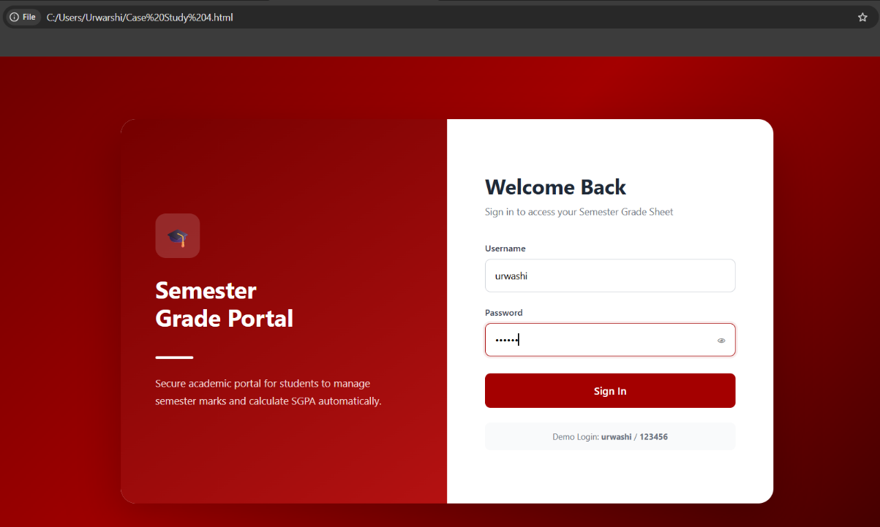
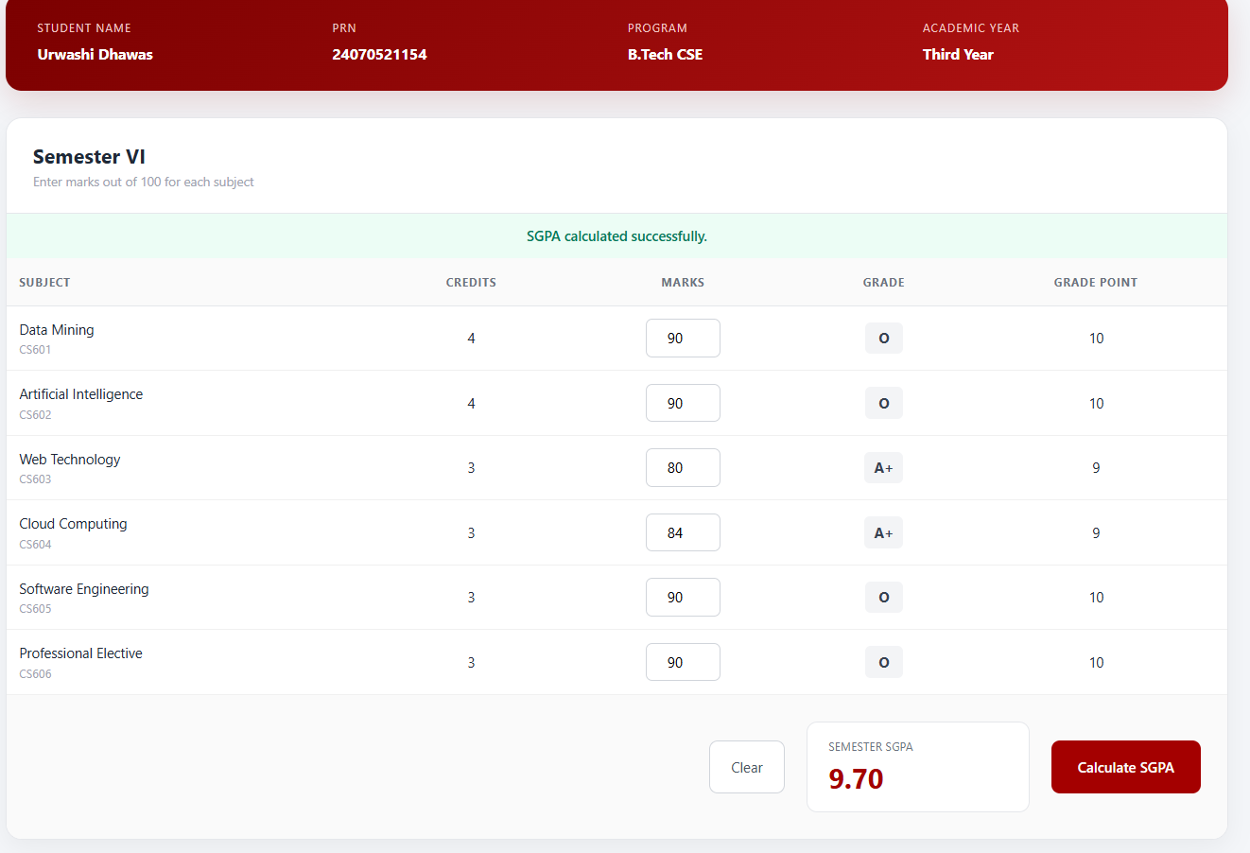

Result/Conclusion:
Successfully developed a professional Semester Grade Sheet web application with secure login, student mark entry, automatic grade calculation, and SGPA calculation using HTML, CSS, and JavaScript.

